1. 
2. We will discuss some of MongoDB utilities that are used for MongoDB data management and monitoring.
3. **NOTE**: These mongoDB utilities are not part of mongoDB shell.

They are independent and separate from mongoDB shell.

1. 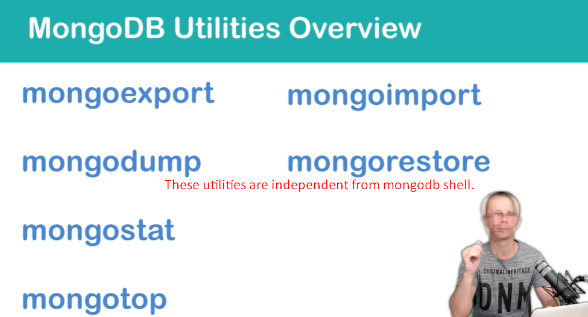
   1. **mongoexport**: Used to export collection data in extended JSON format.
   2. **mongoimport**: Used to import collection data in extended JSON format.
   3. **mongodump**: Used to perform dump in BSON format.
   4. **mongorestore**: Used to restore from dump in BSON format.
   5. **mongostat:** We will see this utility too.
   6. **mongotop:** We will see this utility too.